Elements + Behavior

Components

Use Cases

read text

view text

move the handle to see other parts

drag the view ports to adjust the size of the frame

Classes:

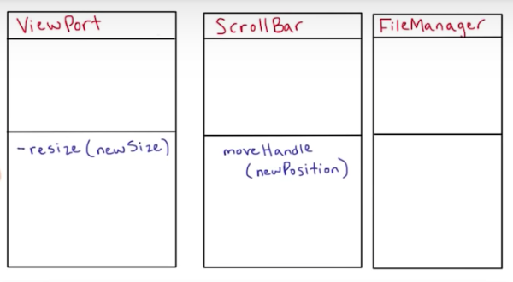

ViewPort:

height

content

ScrollBar:

position of the handle

size

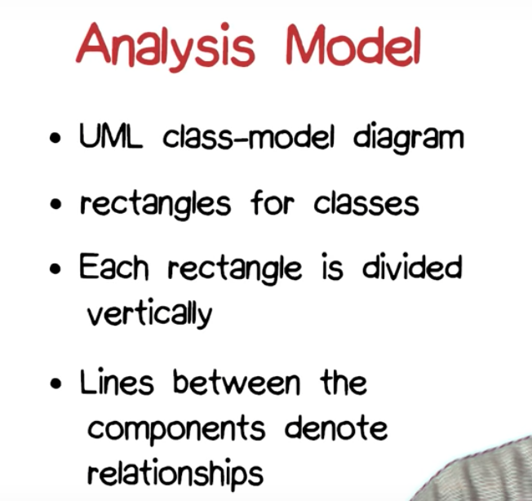

Add the two **externally visible operations**

**visible Attributes**

**If we**

**When perform the operation for effect -> no return value**

**When perform the operation for return value -> return value should be carefully consider**

Analysis model is not design

**Percept 分析:**

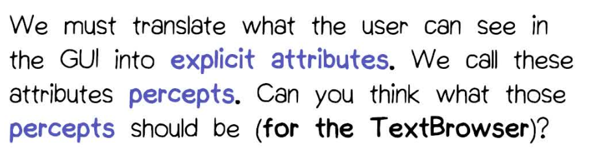

**View text**

**File Manager类分析:**

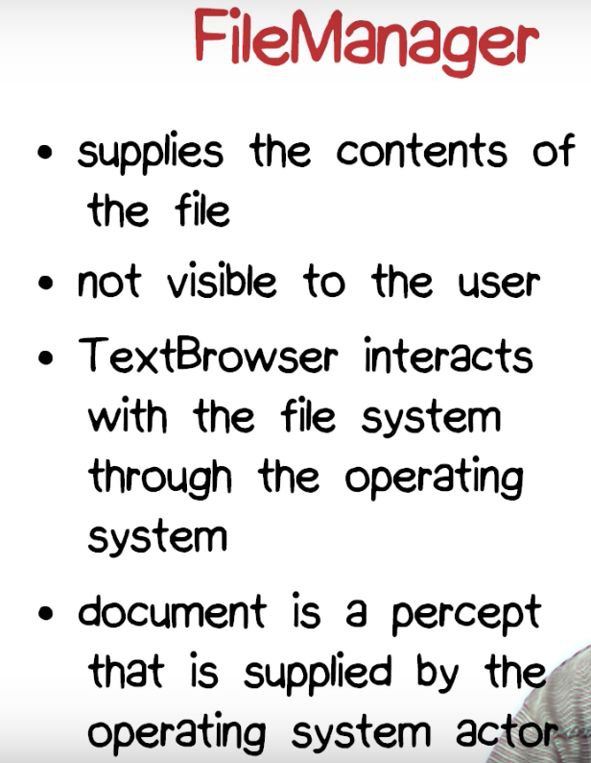

Relationships Analysis:

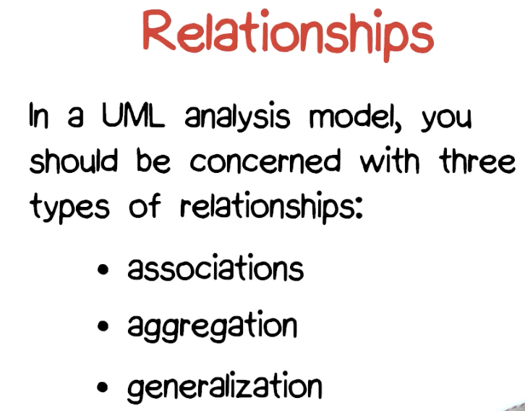

17. Number of Lines Quiz

**OCL: Object Constraint Language**

part of UML to express various requirements that we have to deal with

**Association:**

**Display association:**

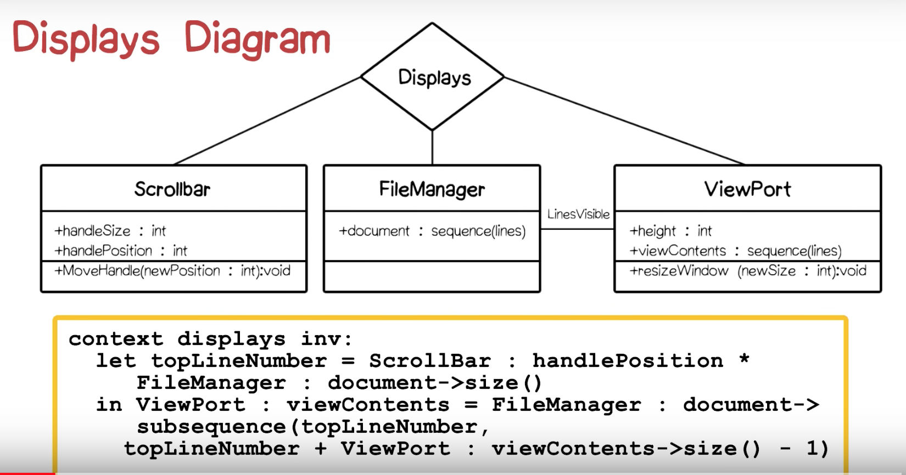

**Summary:**

**What is the key design question with which any implementation of the Text Browser must deal?**

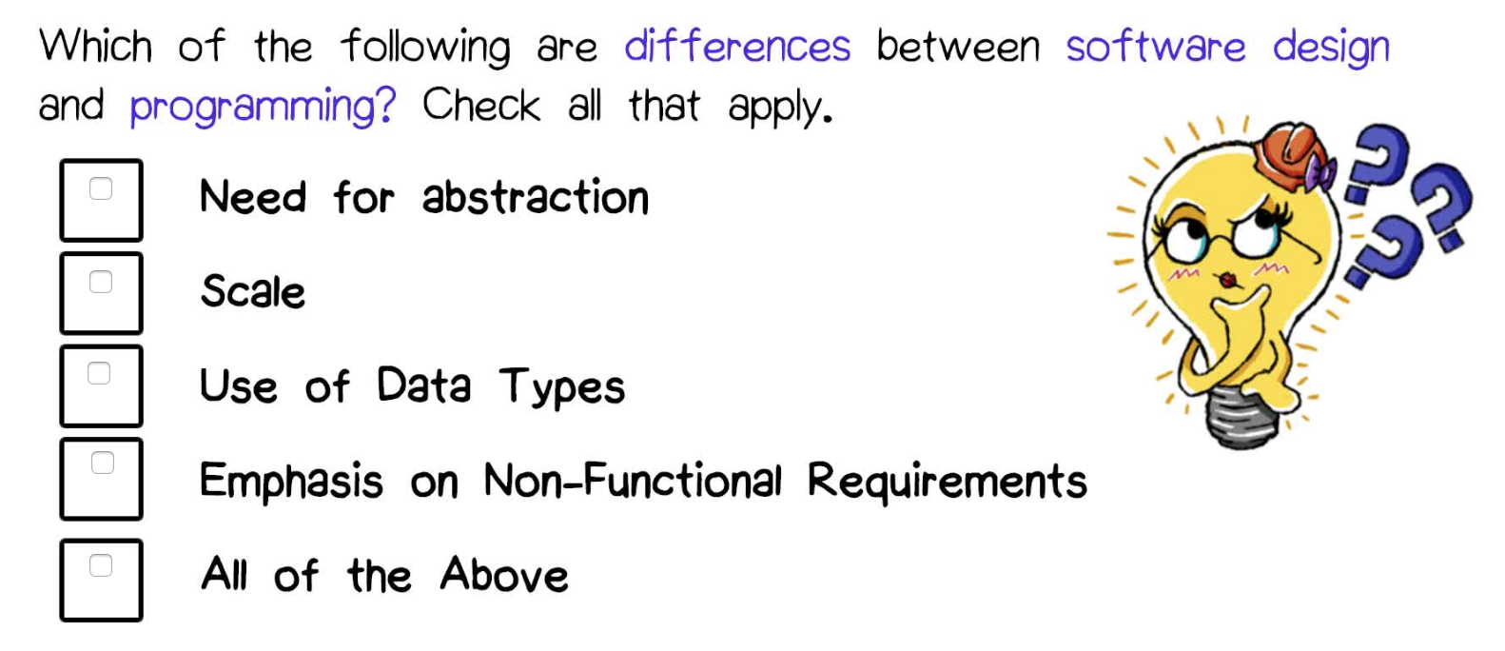

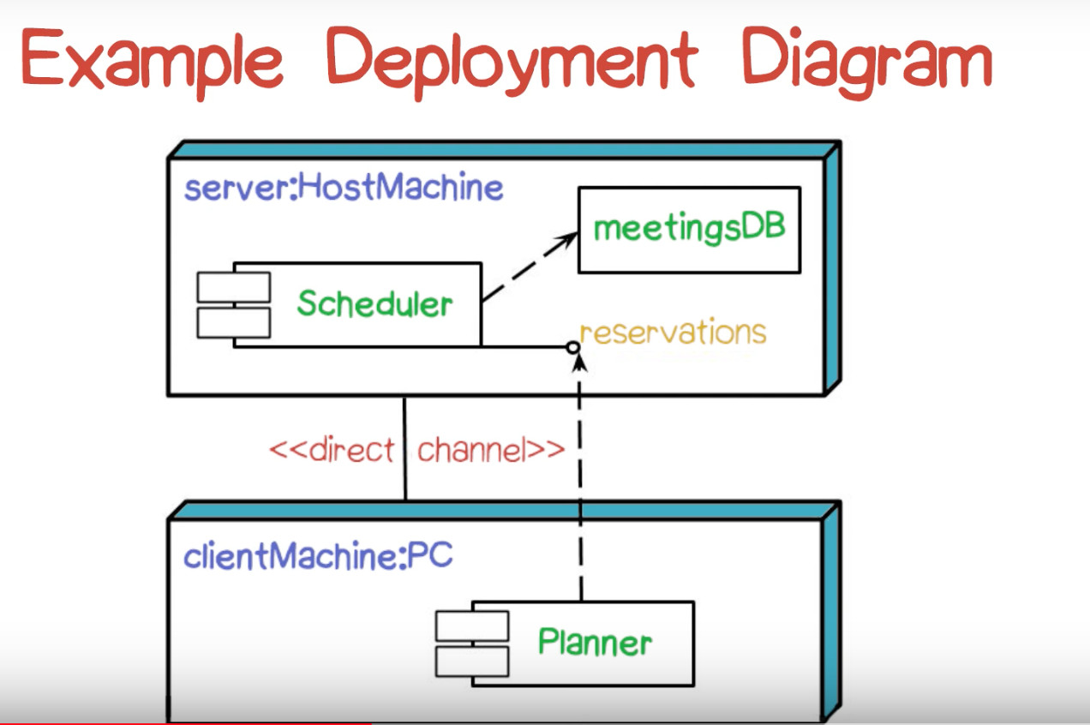

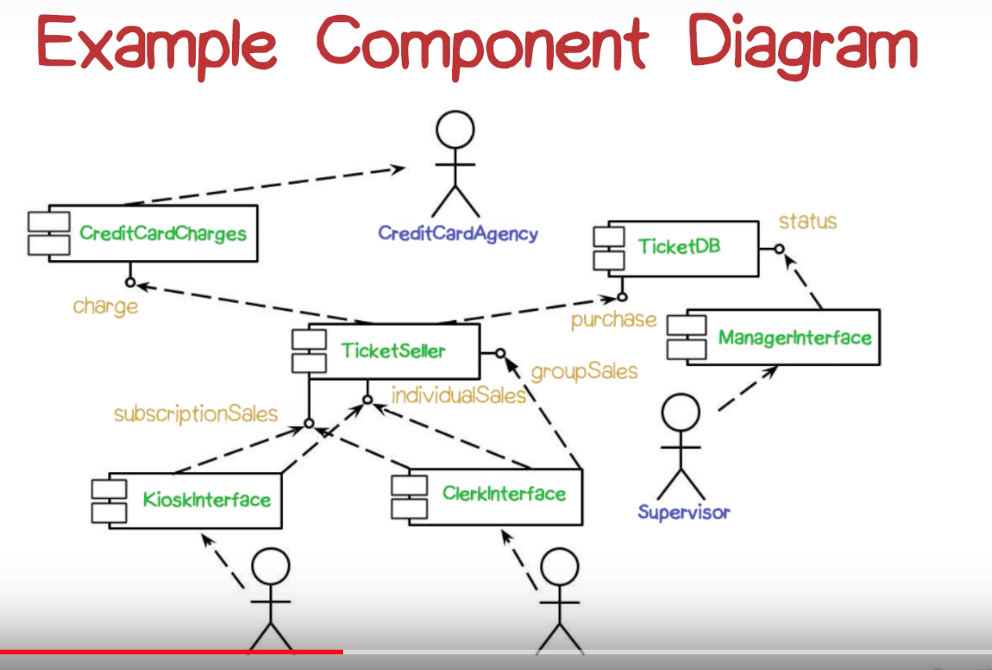

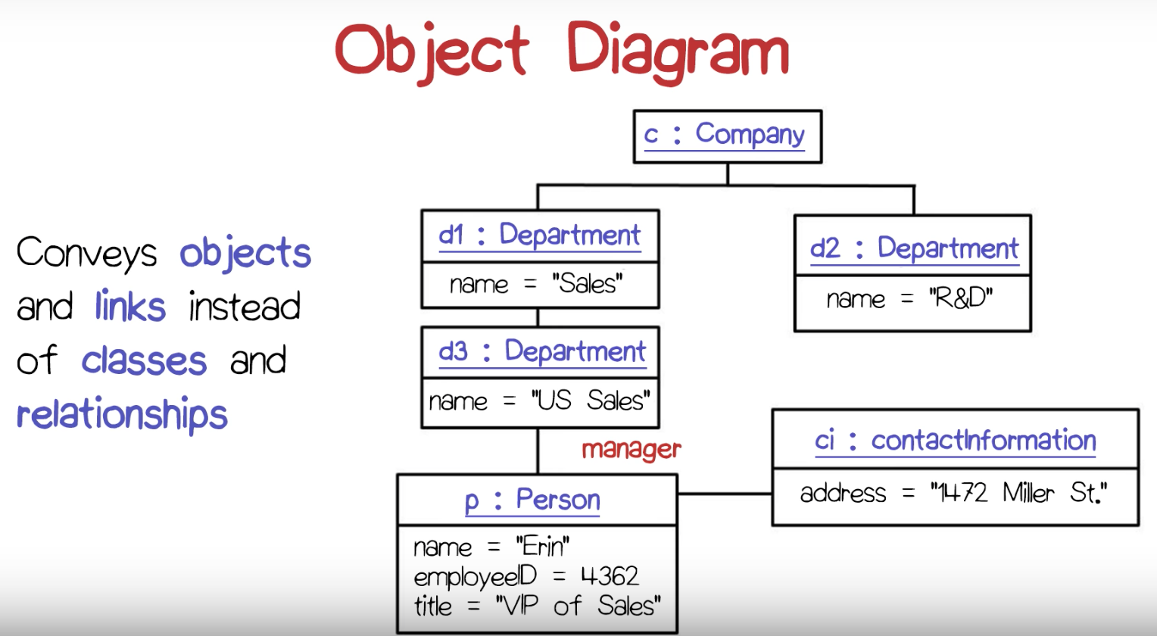

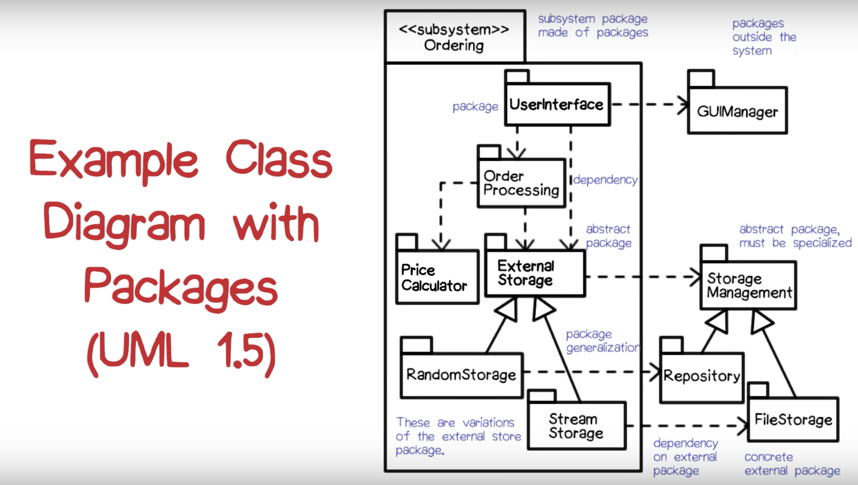

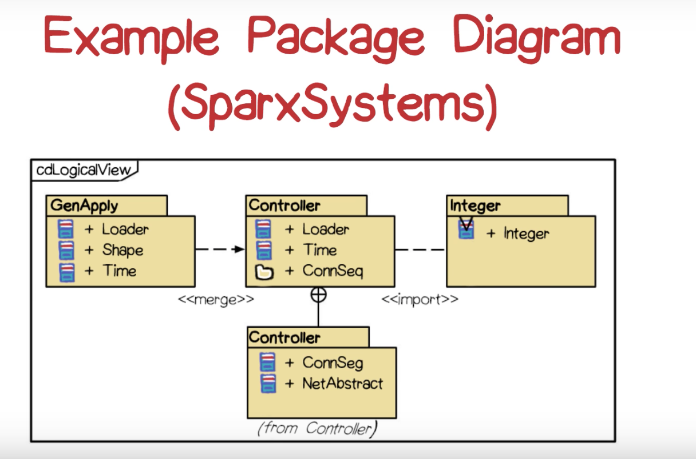

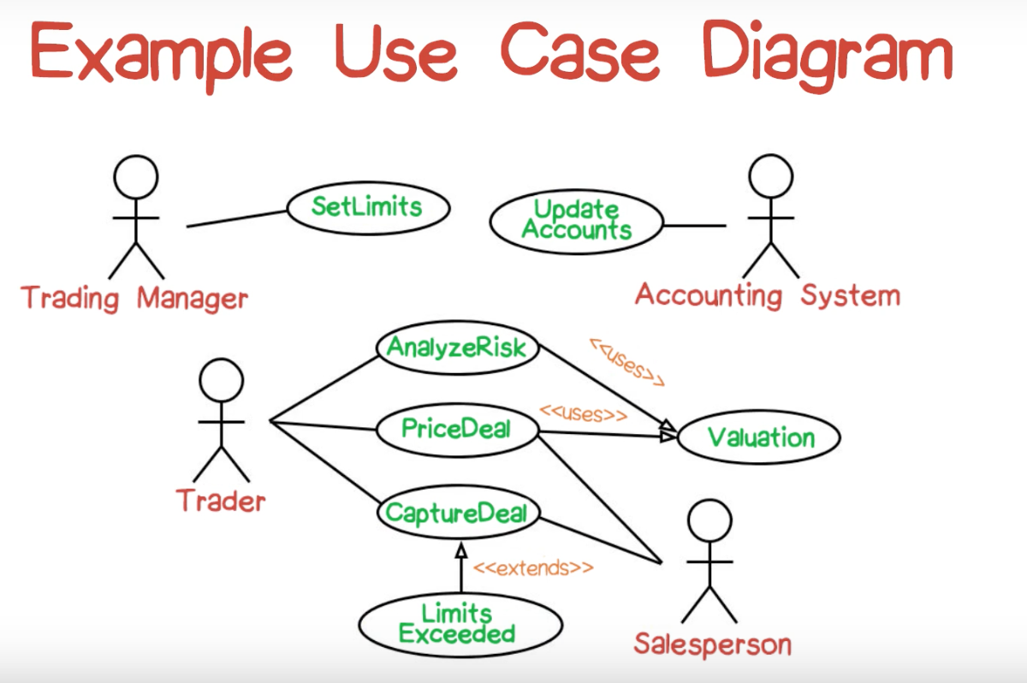

**Sequence Diagram: an interaction of classes in terms of message exchanges**

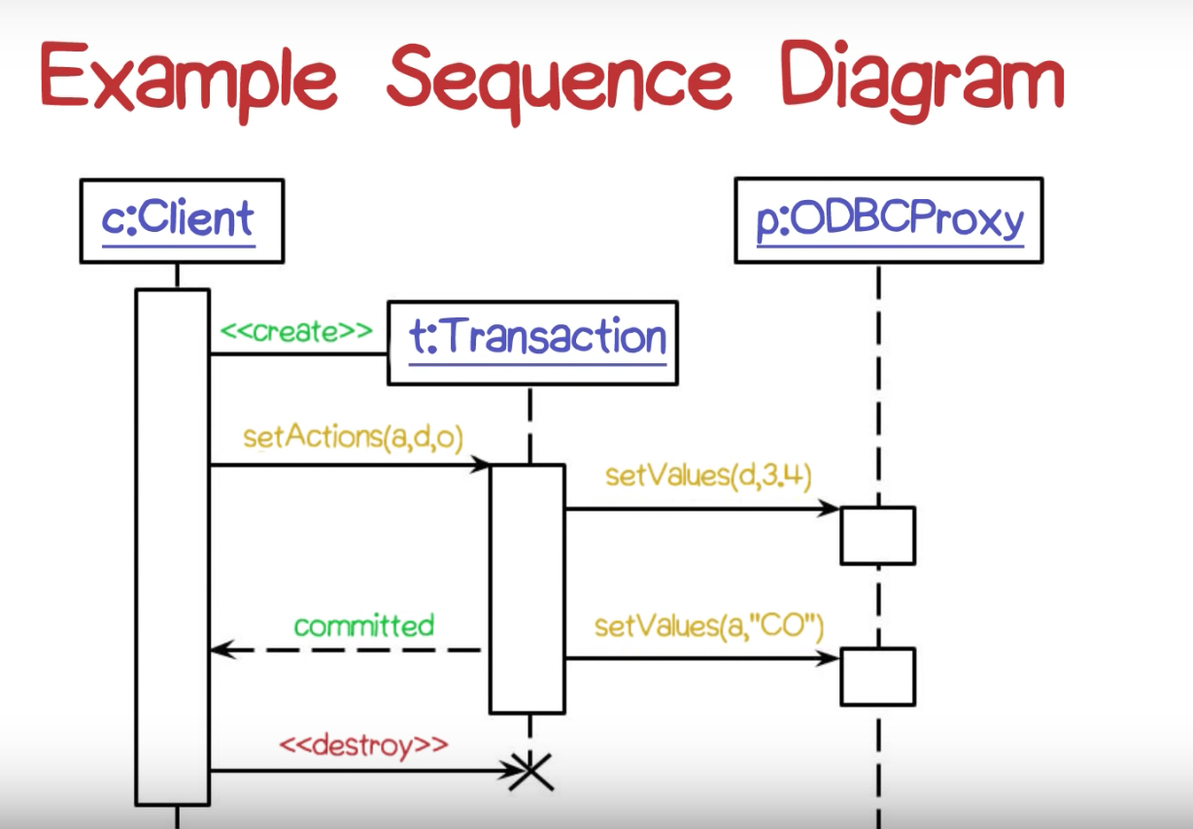

**Activity Diagram: designed for synchronization**

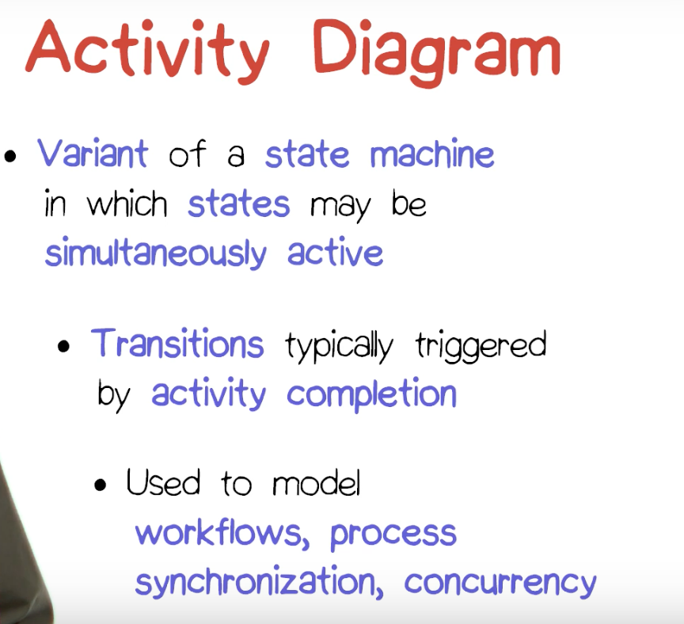

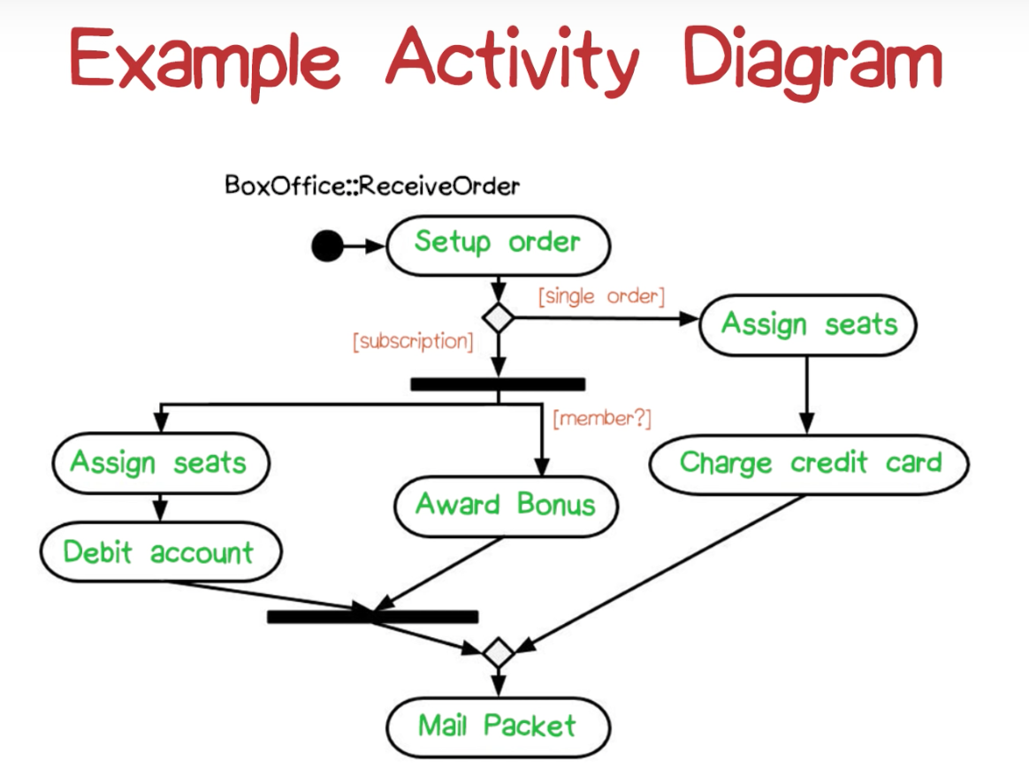

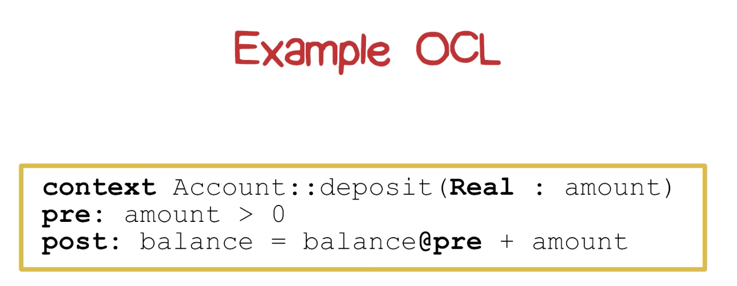

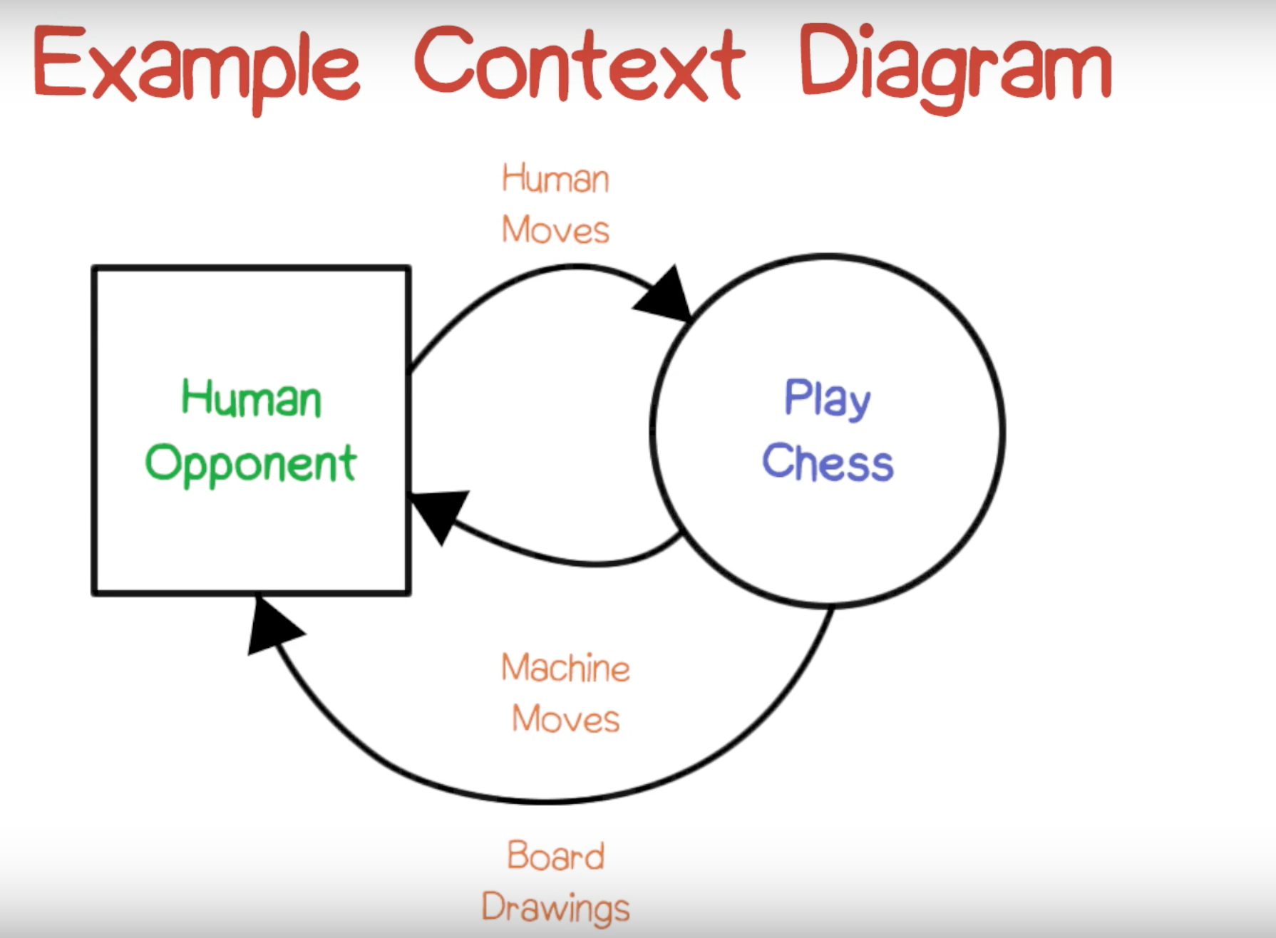

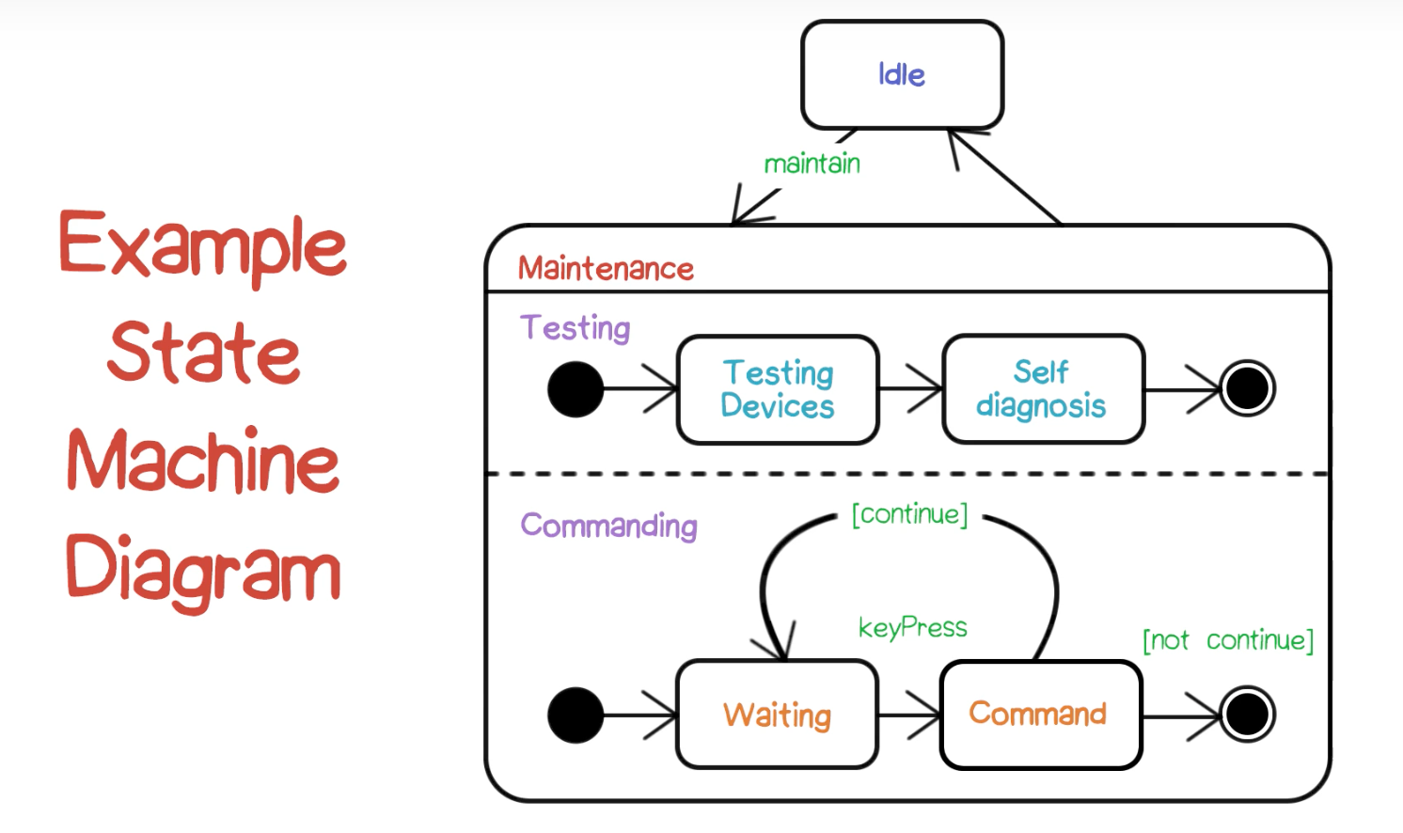

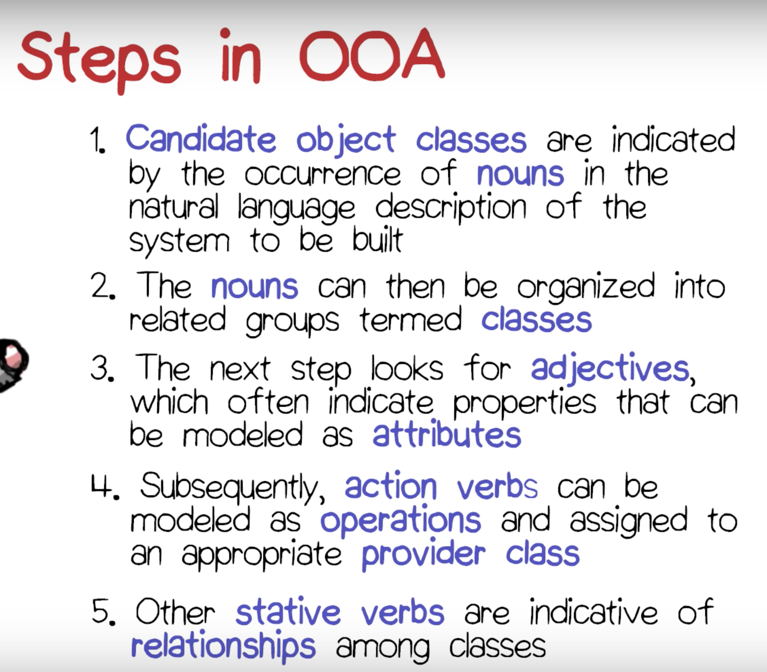

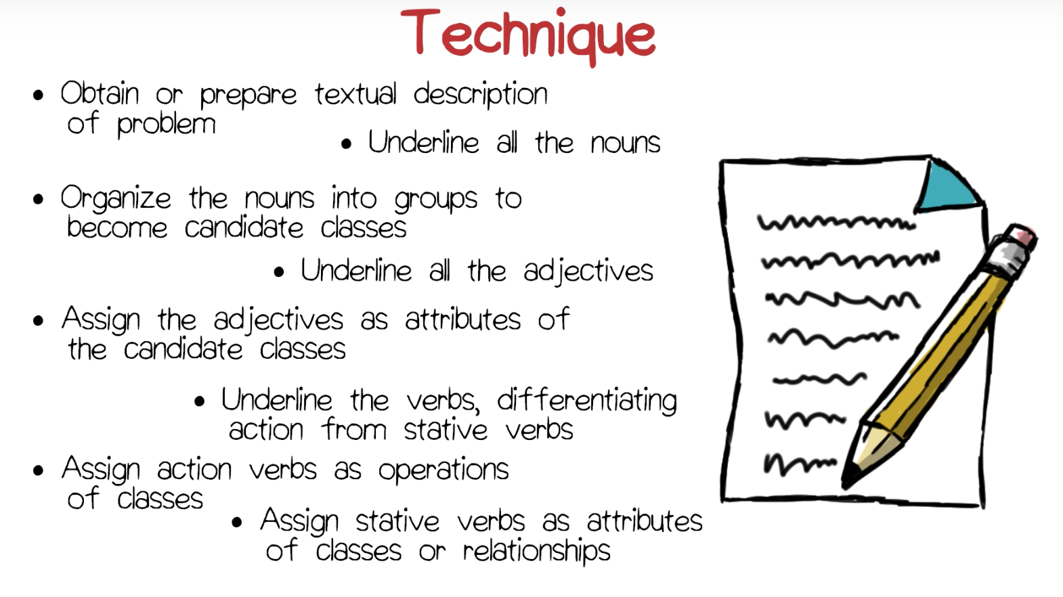

**Analysis Example:**

<https://classroom.udacity.com/courses/ud821/lessons/1662638789/concepts/16346897390923>